**Assignment - React Developer**

This assignment has two parts.This exercise required to move your candidature to next & the final round, i.e. personal round (online)

Part 1- 2.5 hours

Part 2- 2.5 hours

You are required to develop two webpages and integrate to APIs provided to fetch data for display.

**STACK**: CSS3, HTML5, REACTJS

**PART-1**

PAGE 1:

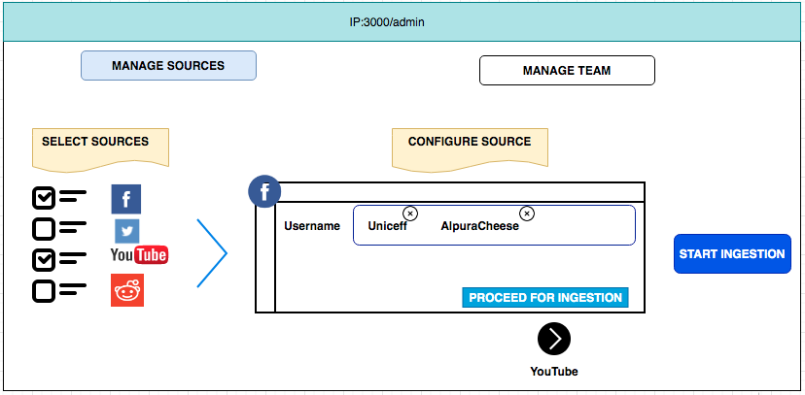

1. There are two tabs, “Manage Sources” and “Manage Team”. The current screen appears when clicked on “Manage Sources”. Clicking “Manage Team”, you can show blank screen

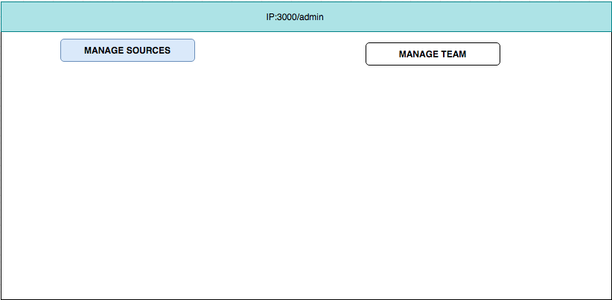

1. Once “Manage Sources” is clicked, we shall see as below

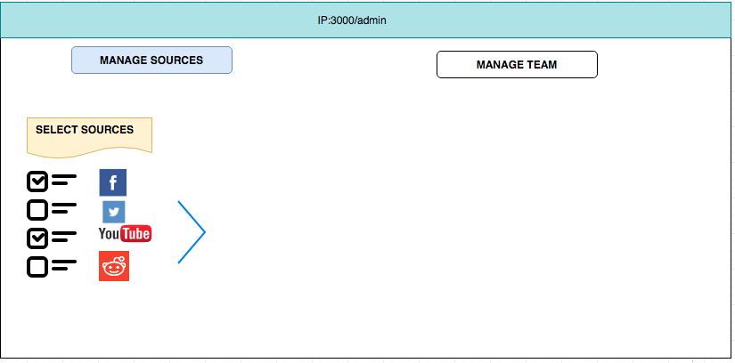

Once select checkbox (atleast one) eg. facebook, then only blue arrow shall be shown (and can be clicked)

1. Once blue arrow is clicked, we shall see as below

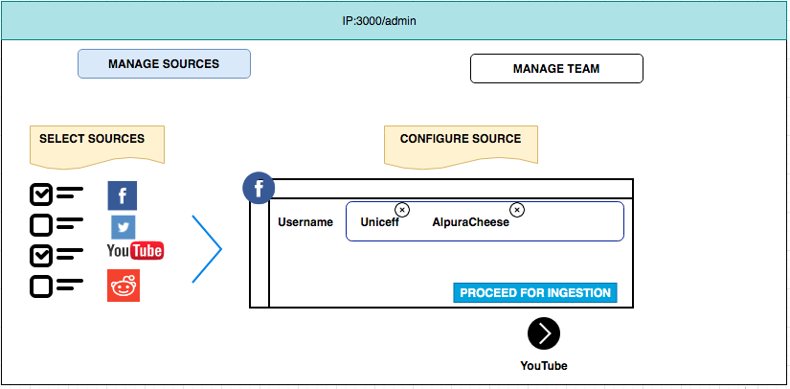

You can observe facebook icon on top left of inner box. We see “Username” and two values (which can be crossed i.e. removed if not needed - this feature is needed to be developed). Also, you can observe black arrow button indicating that it shall lead the inner box changed to that for YouTube (as we selected in checkbox for YouTube)

1. Once we have entered Username for facebook and Pagename for youtube (in next screen), we shall see blue button “start ingestion”

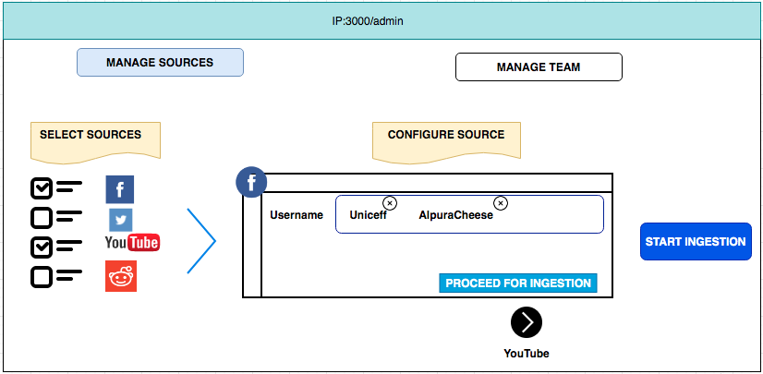

An API shall be called once we clock “start ingestion”. Though you don’t need to ingrate that API for this assignment.

--------

**PART-2**

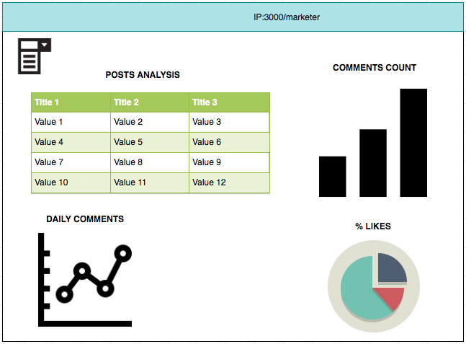

1. The above page consists of four visualizations. The data for them can be fetched from APIs below.
2. You can show all fields for Posts table in “Post Analysis”
3. Top left has a filter. This filter can take multiple value and values would be usernames

GET API details:

user_id=44 for now

* https://assignment-fb.test.intuaition.net/facebook/facebook_post_comments/44
* https://assignment-fb.test.intuaition.net//facebook/facebook_post/44
* https://assignment-fb.test.intuaition.net//facebook/facebook_comments/44

